# **Vehicle Price Prediction**

**Step 1:** Create a new environment to work for every individual project.

( Google 🡪 create conda environment and follow the link )  
  
In this Project we created carprediction environment and to activate the carprediction environment we should use:

Once we activate, we now work in the environment we created:

Note : ‘cls’ can be used to clear the screen

**Step 2:** Open Jupyter Notebook in the location of the dataset to work on

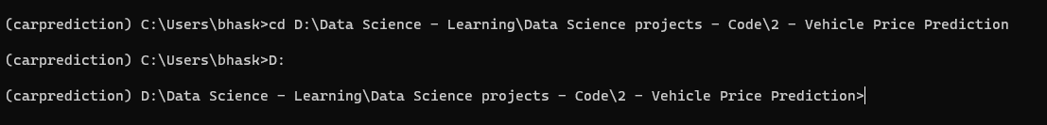 

**Step 3:** Build your model in Jupyter Notebook and finally save the model into a pickle file.  
  
**Step 4:** Creating the Requirement.txt file



( Google 🡪 how to create requirements.txt python and follow the link )